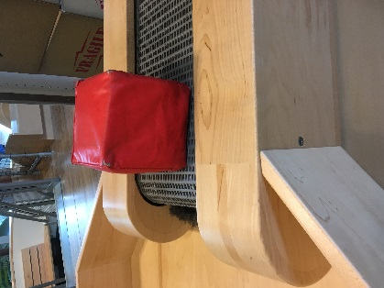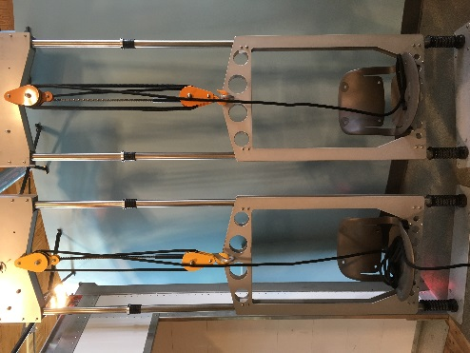**Kindergarten**

General Mills Lift, Load, and Haul

Push

Pull

Speed

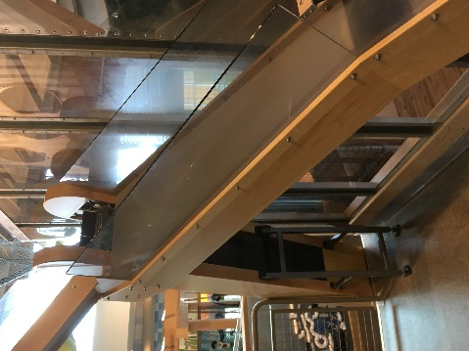Motion

Ramp

Pulley

Wheel

Block

Homestead Cabin & Farm

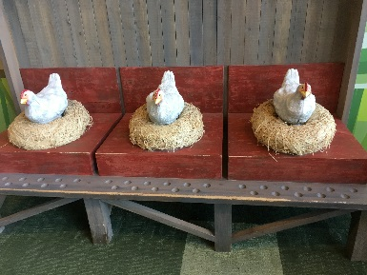Farm

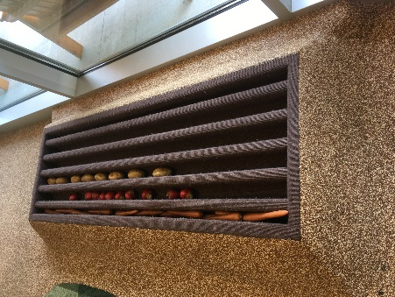Garden

Natural resources

Environment

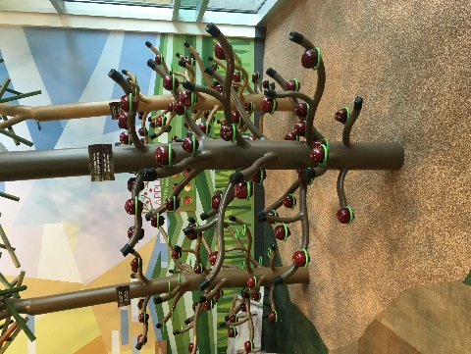Cabin

Wood

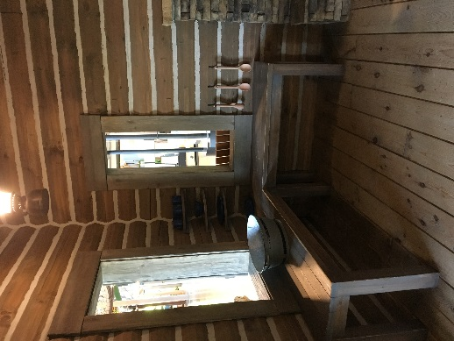Vegetables

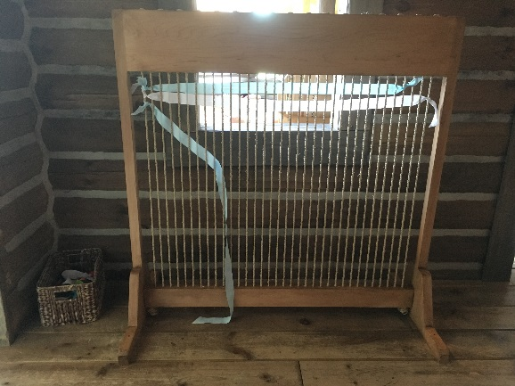Animals

Weaving

Cloth

Cook

Wash

Living

Non-living

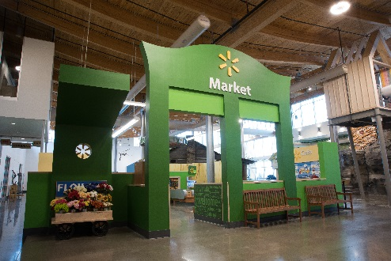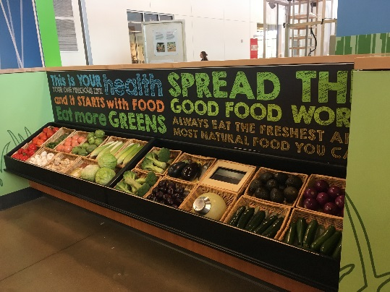Market

Food groups

Dairy

Vegetables

Fruits

Meat

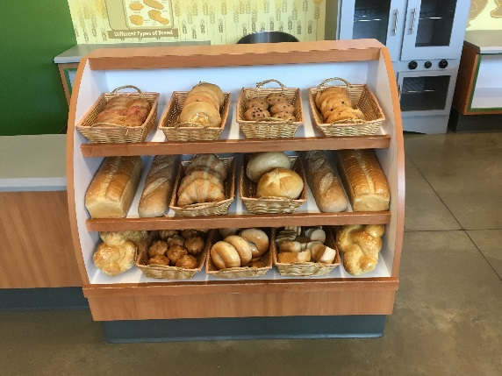Seafood

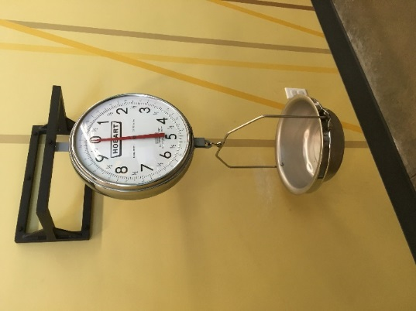Weigh

Grain

Bread

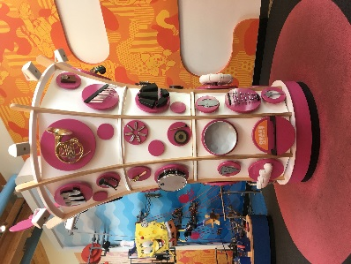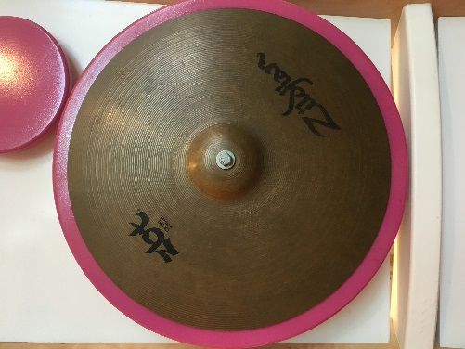**1st Grade**

Nickelodeon PlayLab

Sound

Matter

Music

Instruments

Vibrate

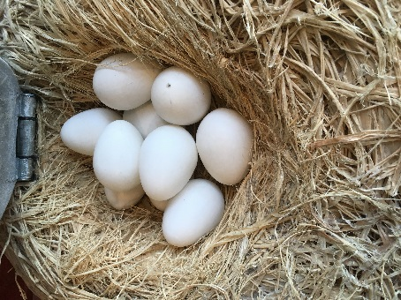

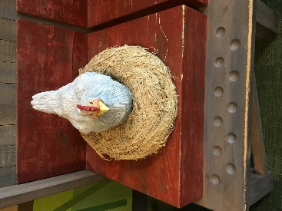Homestead Cabin & Farm

Parent

Offspring

Market

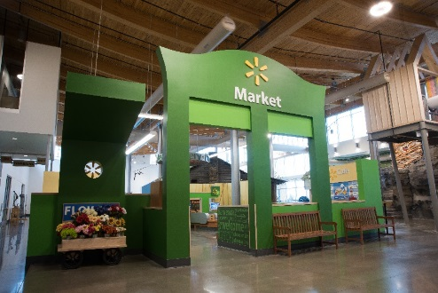Carbohydrates

Nutrients

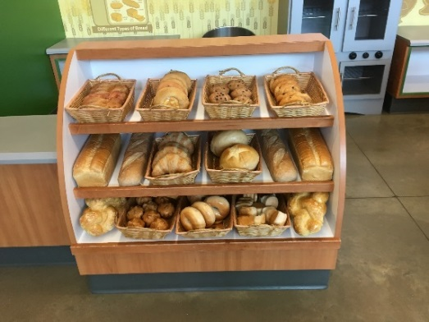Protein

Fat

Vitamin

Mineral

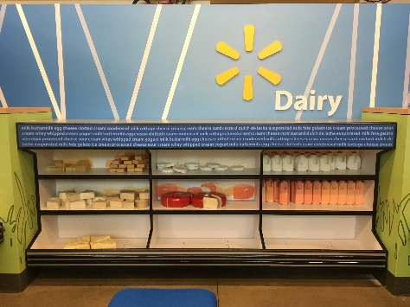Water

Energy

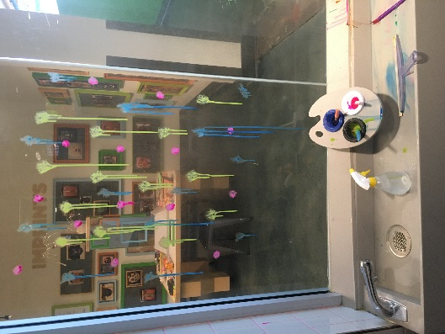**2nd Grade**

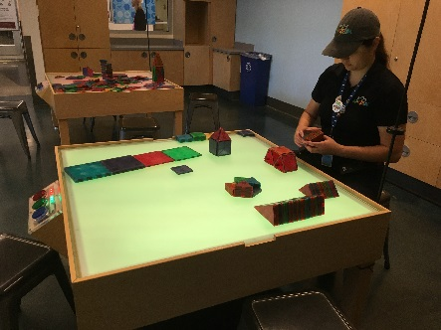Art Studio

Piece

Solid

Liquid

Build/assemble

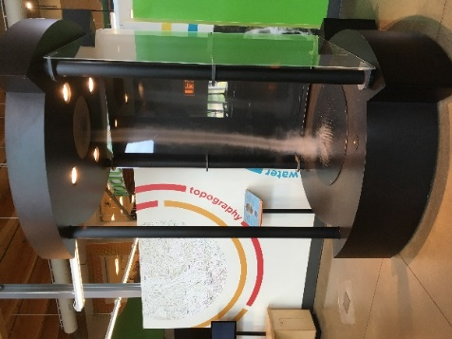Weather & Nature

Earth

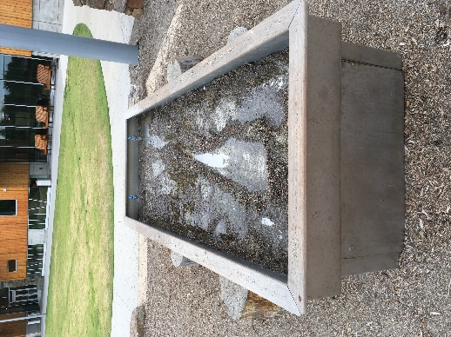Tornado

Wind

Landforms

Storm

Volcano

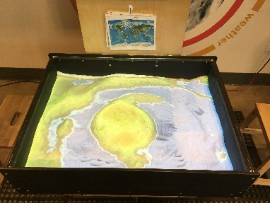Sand

Earthquake

Erosion

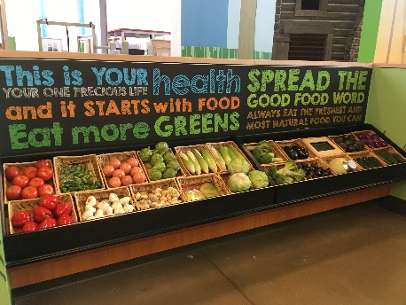Rill

Market

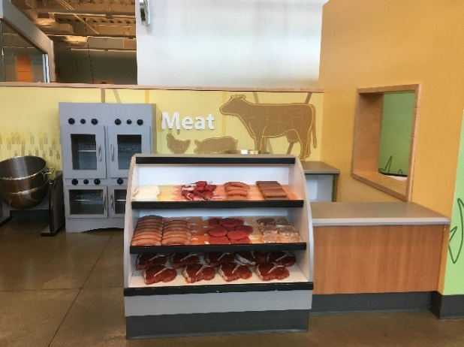Nutrients

Carbohydrates

Protein

Fat

Minerals

Vitamin

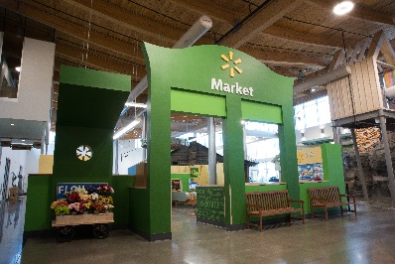Energy

**3rd Grade**

General Mills Lift, Load, and Haul

Force (balanced/unbalanced)

Motion

Rest

Ramp

Pulley

Cave

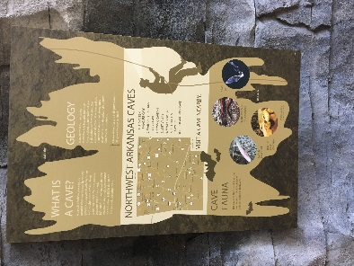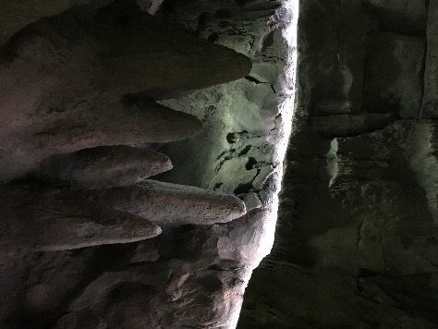Habitat

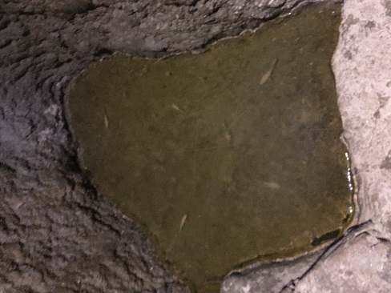Stalactite

Stalagmite

Gray bat

Ozark cavefish

Geode

Temperature

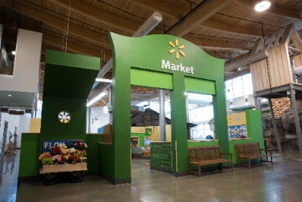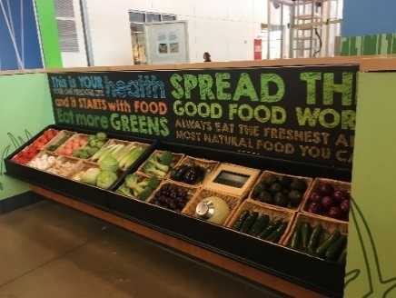Market

Nutrients

Carbohydrates

Fat

Vitamin

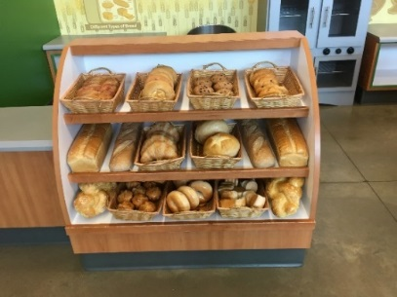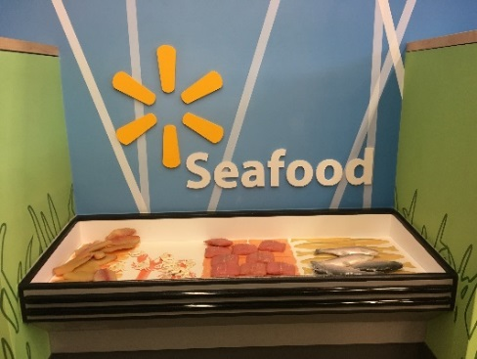Minerals

Protein

Iron

Vitamin C

Grain